Name _____________________________________ Class _____________ Date ____________

Practice Unit 1.1 W-1 Points, Lines, and Planes

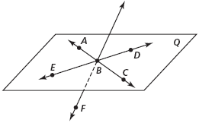
Refer to the diagram at the right for Exercises 1–15.
- Name in another way.

- Give two other names for plane Q.

- Why is EBD not an acceptable name for plane Q?

Are the following sets of points collinear?
4. and C 5. B and F
6. and A

Are the following sets of points coplanar?
7. E, B, and F

8. and 9. and

10. F, A, B, and C

Find the intersection of the following lines and planes in the figure at the right, If they do not intersect, state they do not intersect.
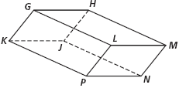
11. and

12. planes GLM and LPN

13. planes HJN and GKL

14. and plane KJN

Refer to the diagram at the right.
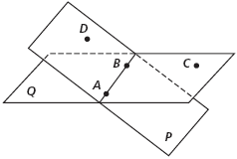
15. Name plane Q in another way.

16. What is the intersection of planes P and Q?

17. Are A and C collinear?

18. Are D, A, B, and C coplanar?

19. Are and plane Q coplanar?

